Experiment 6
File Creation and Download Commands
Aim
To execute touch, pwd, and wget commands.
Theory
touch Command
Creates an empty file.
touch sample.txt
pwd Command
Displays current working directory.
pwd
wget Command
Downloads files from the internet.
wget https://example.com/file.zip

Procedure
- Create a file using touch.
- Display current directory using pwd.
- Download a sample file using wget.
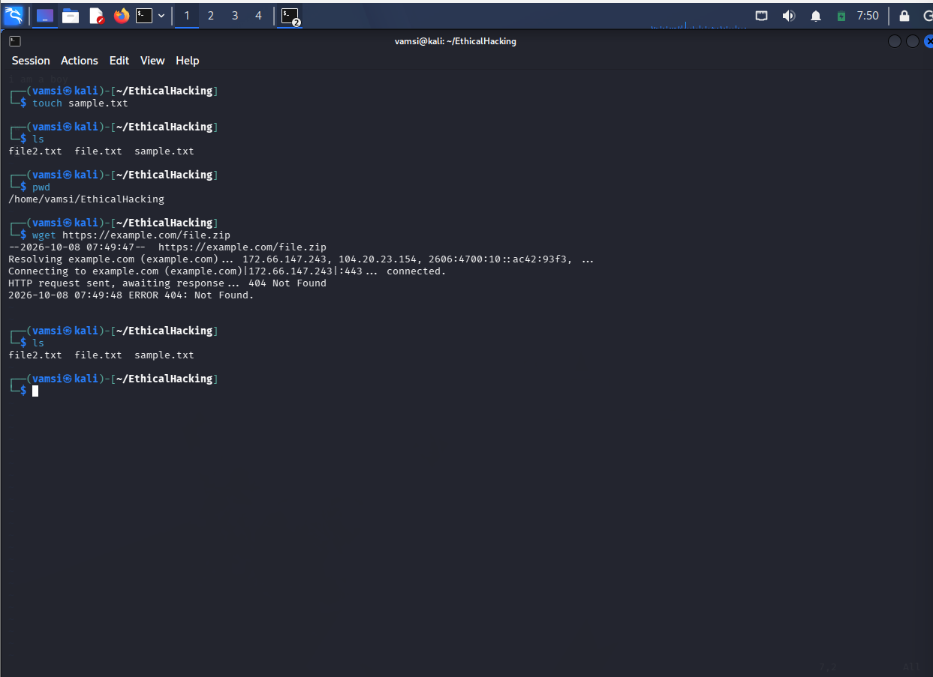
Result
Successfully executed touch, pwd, and wget commands.

